ID: 27377

Name: Vinay Kumar G

**INFOGRAPHIC ILLUSTRATION ON TEST DRIVEN DEVELOPMENT**

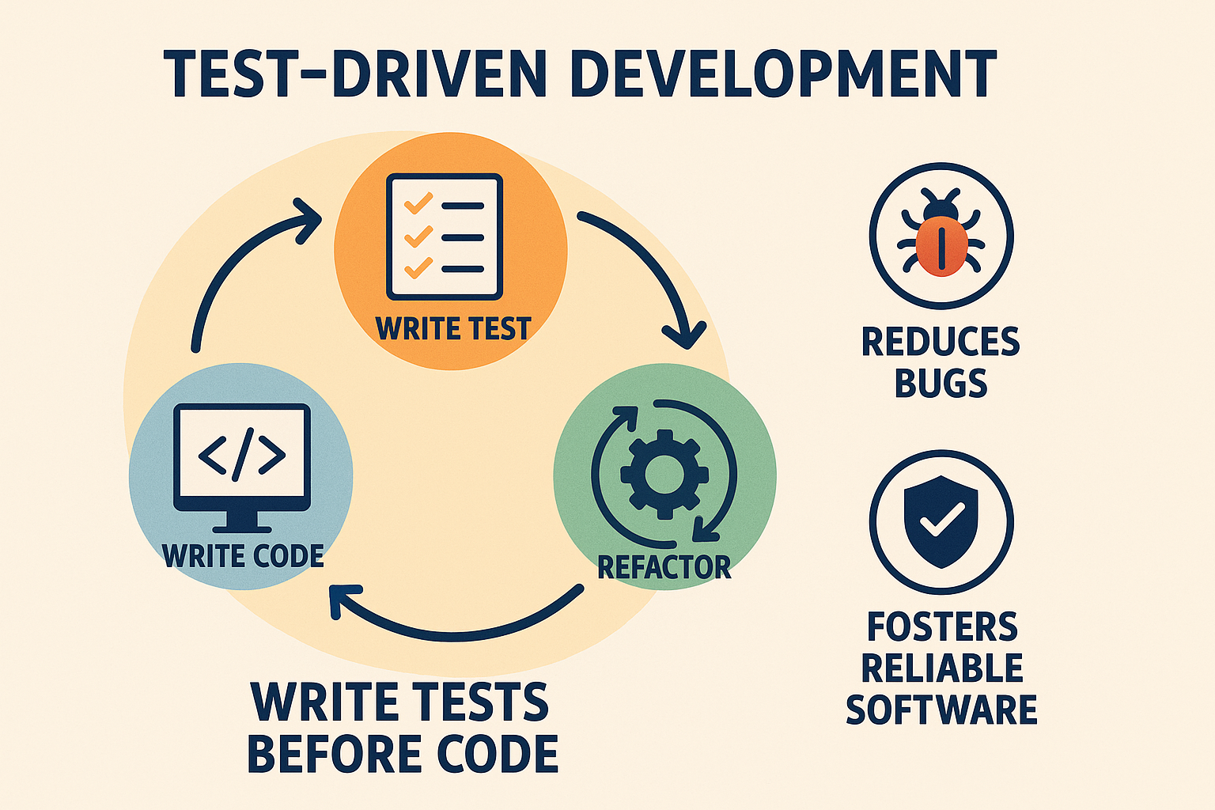

**The infographic shows the Test-Driven Development (TDD) cycle in three steps:**

* Write Test (before coding)
* Write Code (to pass the test)
* Refactor (improve the code)

It highlights TDD benefits like reducing bugs and creating reliable software.